|  |  |  |
| --- | --- | --- |
|  | | |
|  |  | |
|  |  | |
| [NAME ATTENDEE AS ON PASSPORT] | | P.O. Box 77777  ‑NL‑1070 MS Amsterdam  Europaplein 24  ‑NL‑1078 GZ Amsterdam  T +31 (0)20 549 12 12  www.rai.nl  T direct +31 (0)20 549 1668  (PA Mr. P. Riemens)  E: m.v.buuren@rai.nl |
| Date: 9 September 2021  Our ref: PR/mvb  Re: Invitation Aviation Week MRO Europe | |

Dear [NAME ATTENDEE],

With this letter, RAI Amsterdam B.V. (**RAI**) would like to invite you, also on behalf of Informa Markets, a trading division of Informa PLC (the **Organiser**), to attend Aviation Week MRO Europe (the **Event**)in the RAI Amsterdam Convention Centre from 16 to 22 October 2021. This letter of invitation is written to you to support your application for the business traveller exemption from the quarantine obligation as such applies in The Netherlands for travellers from a very high-risk area as of the date hereof.

**The importance of the Event**

MRO Europe is the region's premier event for the commercial air transportation maintenance, repair and overhaul industry. The Event is for everyone involved in the MRO industry to exchange ideas and best practices, share experiences, discuss issues and challenges, and gain knowledge. This industry is of great importance to the Dutch economy.

In general, international events in RAI produce an enormous spin off to the Dutch economy. Independent research has shown that every €1 spend in RAI leads to a spend of €7 in the region. With a total revenue for RAI of almost €850,000, the Event is expected to bring an economic spin-off of at least €5,8 million to the region.

**The importance of your attendance**

As you are aware, an EU entry ban is in effect for people from countries outside the EU. This means they generally are not allowed to enter the EU or Schengen area and therefore the Netherlands and, if an exemption applies, must quarantine upon arrival. However, *business* *travellers* are exempted from both these rules. For more information, please see <https://www.government.nl/topics/coronavirus-covid-19/visiting-the-netherlands-from-abroad/exemptions-to-the-entry-ban>.

This letter of invitation is to support your application for the *business* *traveller* exemption based on the fact that:

1. You are entering The Netherlands for the purposes of visiting the Event, which takes place only on the dates set out above;
2. The Event contributes significantly to the Dutch economy, to the local economy of the city of Amsterdam as well as to RAI and its suppliers (see also above); and
3. Your physical presence at the Event is essential in view of your contribution (i) in terms of knowhow and (ii) to the success of the Event.

Upon arrival in the Netherlands, you will be asked to fill out a separate [Quarantine Declaration](https://www.rijksoverheid.nl/binaries/rijksoverheid/documenten/publicaties/2021/05/20/quarantaineverklaring/quarantine-declaration-en-20210729.pdf) on your own recognisance and to show this letter of invitation as part of your application.

We wish you safe travels and look forward to seeing you at the Event!

Yours sincerely,

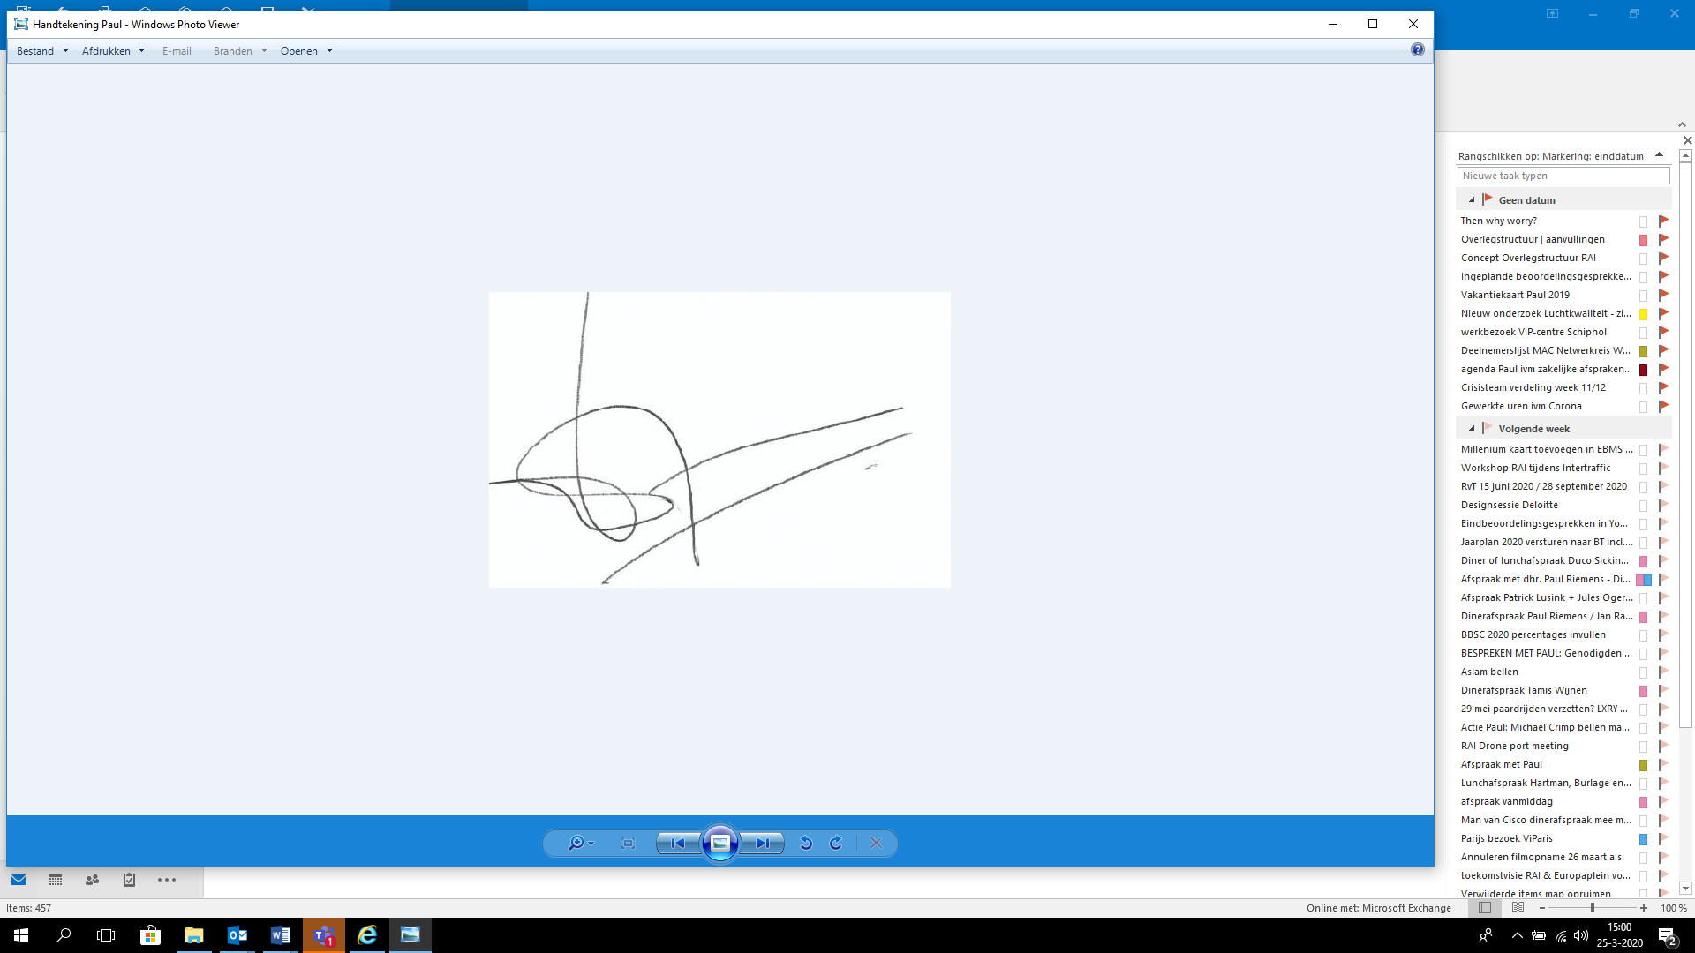

P. Riemens

CEO RAI Amsterdam